Xihao Zhu’s lab01 documentation

Problem1.

I have used matlab before.

Problem2.

I used GNU Octave to do this homework.(GNU Octave is pretty much like Matlab, but just a free version, if you have any problem running my code please contact me. My email is [zhuxh529@gmail.com](mailto:zhuxh529@gmail.com), phone is 6184340261).

Problem3.

Just navigate to my directory, and type “rotate” in command line of Octave.

Result is:

p2 =

0

0

-1

p2 =

0.00000

0.70711

-0.70711

so two rounds get different results, which is what we want(order of matrix calculation is reverse, so results are different).

Problem 4.

(a)

(i)

alpha =[ 10 20 30}

position =[1 2 3]

T=

0.92542 0.01803 0.37852 3.00000

0.16318 0.88256 -0.44097 2.00000

-0.34202 0.46985 0.81380 1.00000

0.00000 0.00000 0.00000 1.00000

(ii)

alpha =[0 20 0]

position=[3 0 1]

T=

0.93969 0.00000 0.34202 1.00000

0.00000 1.00000 0.00000 0.00000

-0.34202 0.00000 0.93969 3.00000

0.00000 0.00000 0.00000 1.00000

(b)

Translated position is

T*[1;0;1;1]=

2.28171

0.00000

3.59767

1.00000

so translated position is

2.28171

0.00000

3.59767

graph sketch:

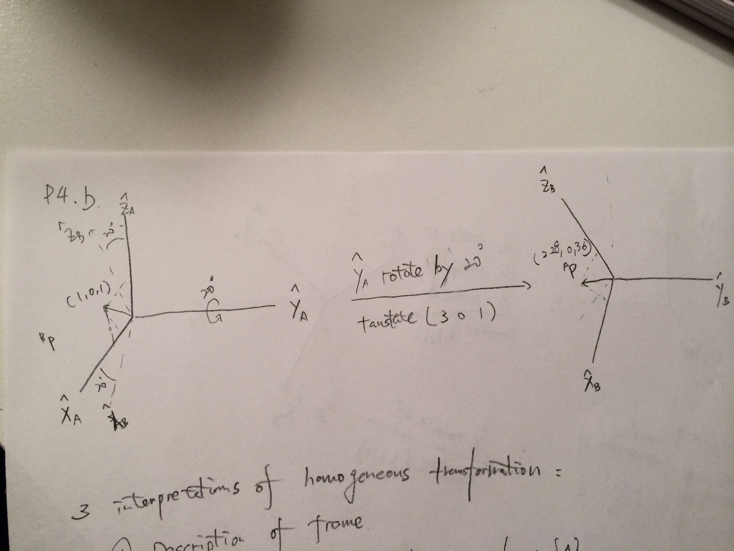

(c.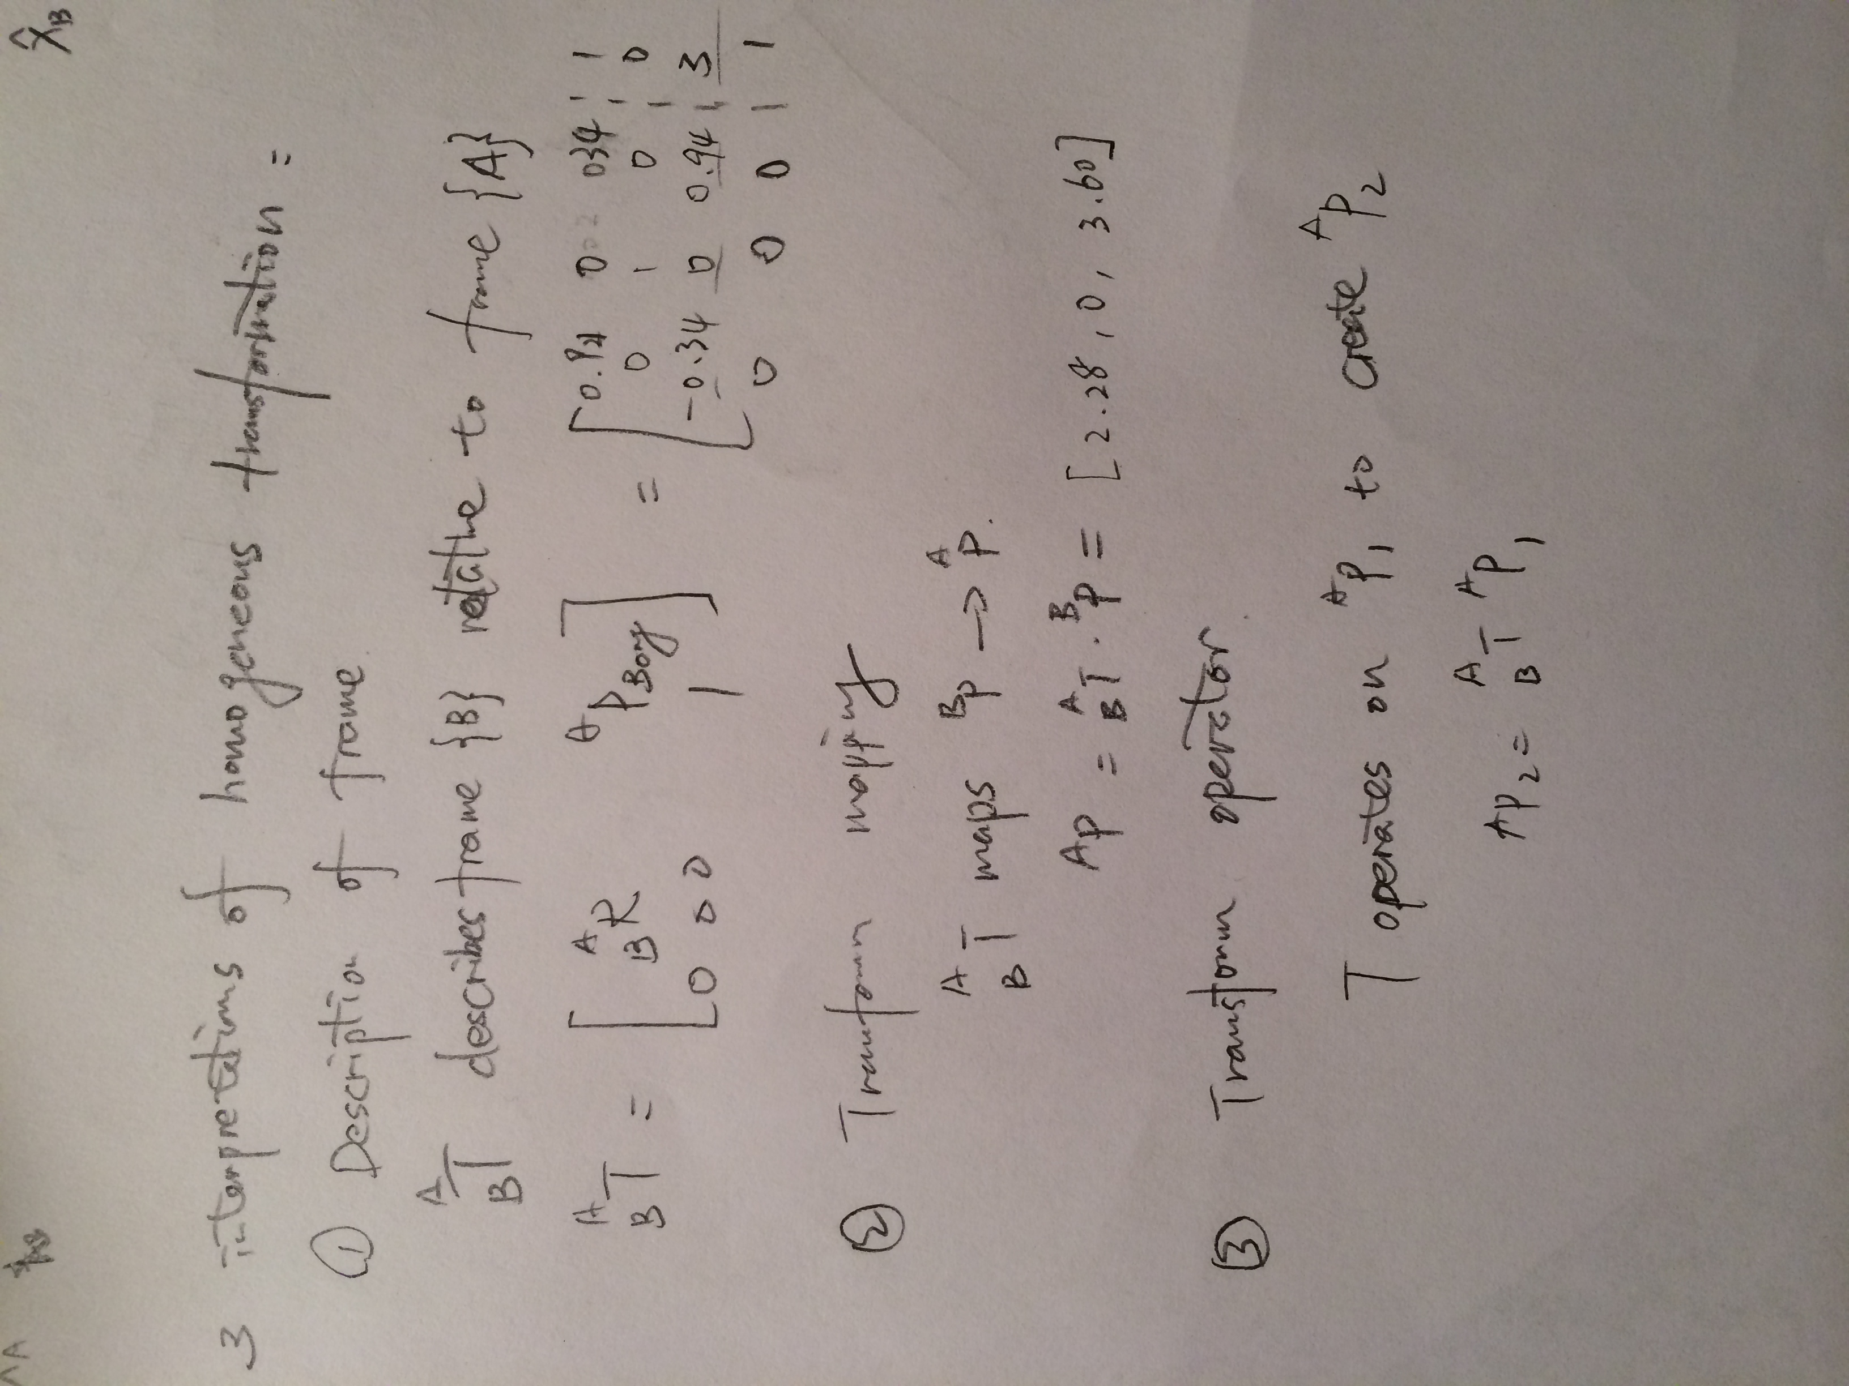

(i)

[T, T_inv]=euler2ht(a,p) gets

T =

0.92542 0.01803 0.37852 3.00000

0.16318 0.88256 -0.44097 2.00000

-0.34202 0.46985 0.81380 1.00000

0.00000 0.00000 0.00000 1.00000

T_inv =

0.92542 0.16318 -0.34202 -2.76058

0.01803 0.88256 0.46985 -2.28906

0.37852 -0.44097 0.81380 -1.06743

0.00000 0.00000 0.00000 1.00000

Then multiply both of T and T_inv

T*T_inv

ans =

1.00000 -0.00000 0.00000 0.00000

-0.00000 1.00000 0.00000 0.00000

0.00000 0.00000 1.00000 -0.00000

0.00000 0.00000 0.00000 1.00000

correct!

(ii)

[T, T_inv]=euler2ht(a,p) gets

T =

0.93969 0.00000 0.34202 1.00000

0.00000 1.00000 0.00000 0.00000

-0.34202 0.00000 0.93969 3.00000

0.00000 0.00000 0.00000 1.00000

T_inv =

0.93969 0.00000 -0.34202 0.08637

0.00000 1.00000 0.00000 0.00000

0.34202 0.00000 0.93969 -3.16110

0.00000 0.00000 0.00000 1.00000

Then multiply both of T and T_inv

T*T_inv

ans =

1.00000 0.00000 0.00000 0.00000

0.00000 1.00000 0.00000 0.00000

0.00000 0.00000 1.00000 -0.00000

0.00000 0.00000 0.00000 1.00000

correct!

(d)

(i)

T(B->A)=

0.93969 0.00000 0.34202 1.00000

0.00000 1.00000 0.00000 0.00000

-0.34202 0.00000 0.93969 3.00000

0.00000 0.00000 0.00000 1.00000

T(C->B)=

0.92542 0.01803 0.37852 3.00000

0.16318 0.88256 -0.44097 2.00000

-0.34202 0.46985 0.81380 1.00000

0.00000 0.00000 0.00000 1.00000

then

T(C->A)=T(B->A)*T(C->B)=

0.75263 0.17764 0.63403 4.16110

0.16318 0.88256 -0.44097 2.00000

-0.63790 0.43535 0.63526 2.91363

0.00000 0.00000 0.00000 1.00000

By using the same method, we can get

T(A->C)=T(B->C)*T(A->B) where the later 2 Ts are T_inv of a.i and a.ii

=

0.75263 0.16318 -0.63790 -1.59950

0.17764 0.88256 0.43535 -3.77273

0.63403 -0.44097 0.63526 -3.60723

0.00000 0.00000 0.00000 1.00000

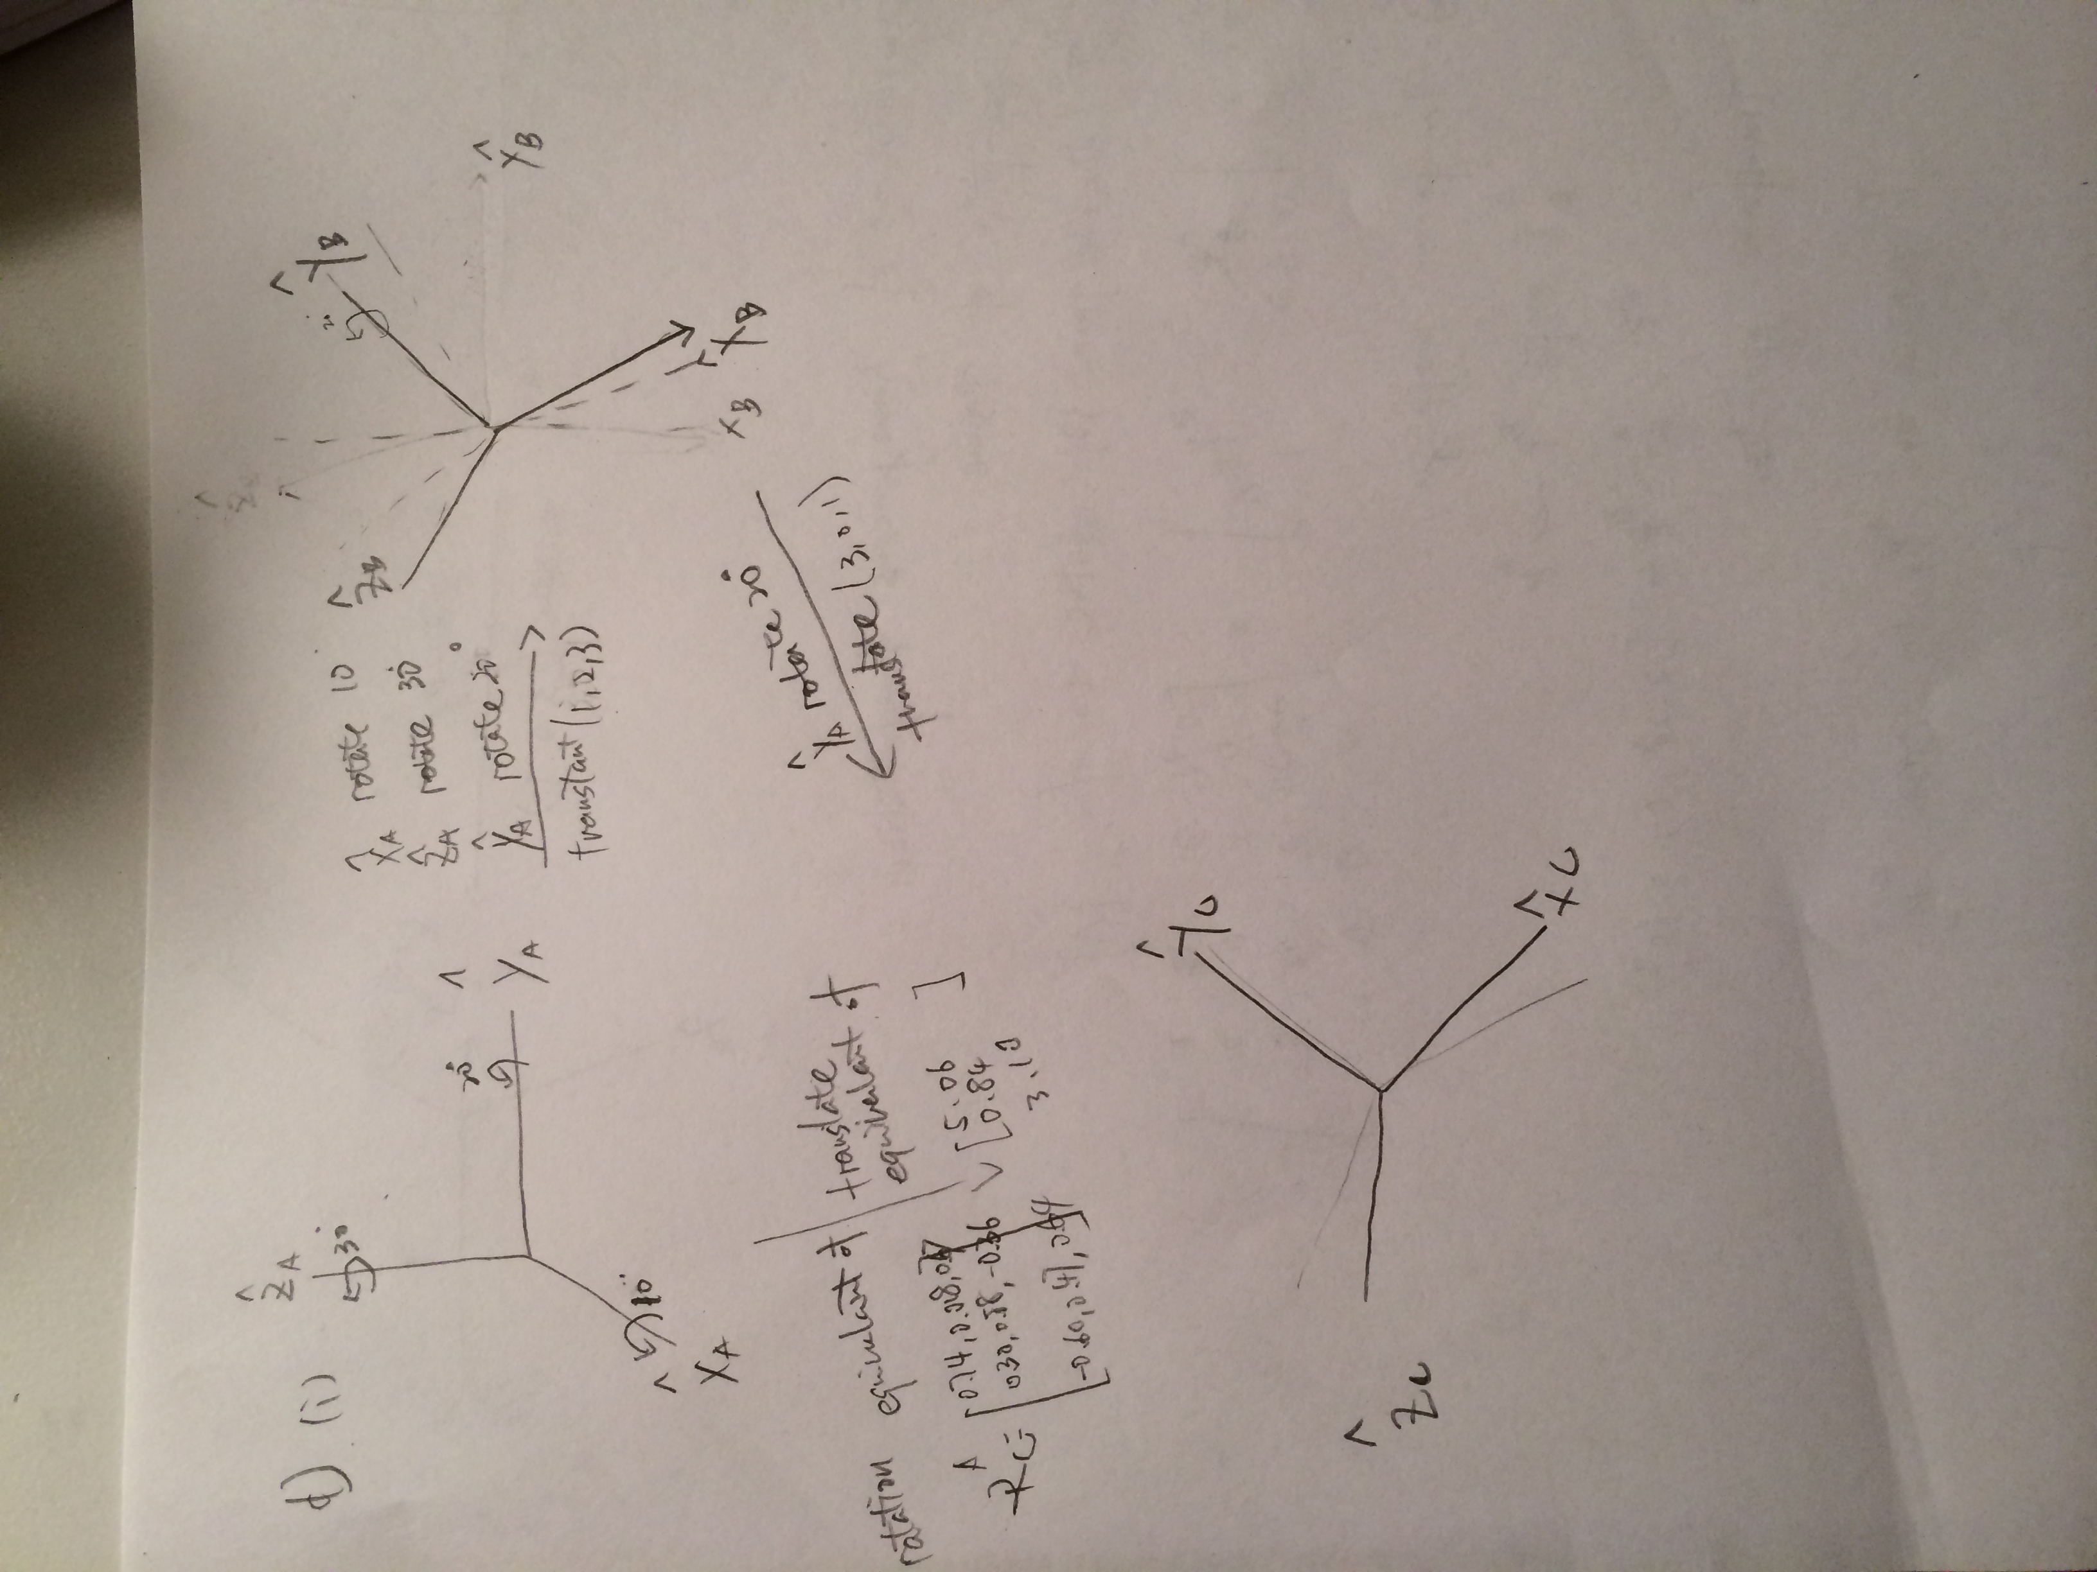check T(C->A)*T(A->C)=I, correct

(ii)

given T(C->A), T(C->B)

we can use inverse transform to get T(B->C), then

T(B->A)=T(C->A)*T(B->C)

=

0.92542 0.01803 0.37852 3.00000

0.16318 0.88256 -0.44097 2.00000

-0.34202 0.46985 0.81380 1.00000

0.00000 0.00000 0.00000 1.00000

It's the same as I calculated before.

(iii)

given T(C->A), T(B->A)

we can use inverse transform to get T(A->B), then

T(C->B)=T(A->B)*T(C->A)=

0.93969 0.00000 0.34202 1.00000

0.00000 1.00000 0.00000 0.00000

-0.34202 0.00000 0.93969 3.00000

0.00000 0.00000 0.00000 1.00000

It's the same as i calculated before.